Canadian Freight Index Highlights:

- Month-over-month: Volumes decreased two percent compared to December 2020.
- Year-over-year: Volumes decreased 13 percent compared to January 2020.
Load and Equipment Trend:

Cross-Border: Cross-border load postings accounted for 72 percent of the data submitted by Loadlink’s Canadian-based customers.

- Inbound cross-border loads (from the United States to Canada) decreased four percent and outbound loads (from Canada to the U.S.) decreased 31 percent year-over-year.
- Inbound cross-border equipment decreased eight percent and outbound equipment decreased seven percent year-over-year.
Cross-Border Loads into Canada by Region of Destination (with M-O-M volume change):
Ontario: 61 percent | + 37%
Western: 17 percent | + 6%
Quebec: 20 percent | + 34%
Atlantic: 2 percent | - 14%

Cross-Border Equipment into Canada by Region of Destination (with M-O-M volume change):
Ontario: 48 percent | - 15%
Western: 31 percent | - 4%
Quebec: 17 percent | - 13%
Atlantic: 4 percent | - 15%

Intra-Canada: Postings accounted for 26 percent of the data submitted by Loadlink’s Canadian-based customers.

Loads within Canada (with M-O-M volume change):

By Region of Origin |  | By Region of Destination
Ontario: 29 percent | - 24% | Ontario: 31 percent | - 28%
Western: 50 percent | - 14% | Western: 47 percent | - 10%
Quebec: 15 percent | - 20% | Quebec: 18 percent | - 22%
Atlantic: 5 percent | - 16% | Atlantic: 4 percent | - 2%
Equipment Breakdown: The top equipment postings were Dry Vans 52 percent, Reefers 27 percent, Flatbed 15 percent, and Other 6 percent.

Loadlink Canadian Spot Market Freight Index 2015- 2021
 | 2015 | 2016 | 2017 | 2018 | 2019 | 2020 | 2021 | Percent Change Y-O-Y | Percent Change M-O-M
Jan | 275 | 199 | 284 | 514 | 294 | 284 | 246 | -13% | -2%
Feb | 253 | 201 | 269 | 468 | 305 | 278
Mar | 285 | 236 | 357 | 496 | 283 | 330
Apr | 249 | 207 | 283 | 402 | 236 | 146
May | 258 | 252 | 330 | 406 | 263 | 154
Jun | 263 | 247 | 358 | 401 | 246 | 219
Jul | 197 | 197 | 304 | 312 | 225 | 228
Aug | 196 | 220 | 341 | 297 | 229 | 233
Sep | 210 | 231 | 322 | 252 | 215 | 260
Oct | 197 | 213 | 333 | 257 | 225 | 265
Nov | 182 | 226 | 354 | 246 | 239 | 271
Dec | 178 | 258 | 364 | 225 | 252 | 250

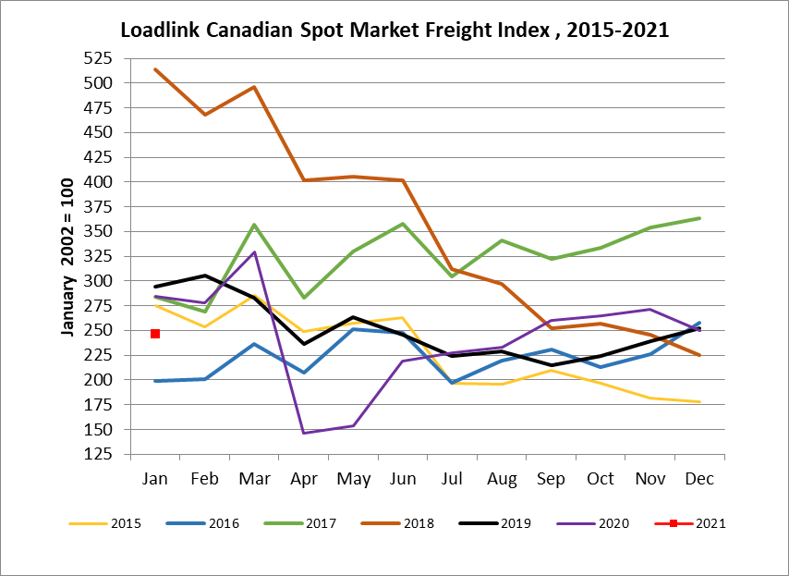

Loadlink Canadian Spot Market Truck Index 2015 - 2021
 | 2015 | 2016 | 2017 | 2018 | 2019 | 2020 | 2021 | Percent Change  Y-O-Y | Percent Change M-O-M
Jan | 112 | 144 | 136 | 99 | 170 | 173 | 166 | -4% | 6%
Feb | 110 | 157 | 130 | 90 | 149 | 153
Mar | 127 | 164 | 145 | 104 | 179 | 163
Apr | 142 | 164 | 130 | 121 | 203 | 188
May | 140 | 163 | 152 | 141 | 214 | 184
Jun | 151 | 170 | 142 | 133 | 186 | 191
Jul | 166 | 162 | 137 | 158 | 213 | 197
Aug | 155 | 179 | 149 | 172 | 202 | 186
Sep | 158 | 163 | 132 | 154 | 191 | 192
Oct | 164 | 161 | 138 | 189 | 210 | 198
Nov | 159 | 163 | 130 | 179 | 186 | 184
Dec | 151 | 133 | 95 | 144 | 160 | 165

