Canadian Freight Index Highlights:

- Month-over-month: Volumes increased 42 percent compared to May 2020.
- Year-over-year: Volumes decreased 11 percent compared to June 2019.
Load and Equipment Trend: June load volumes on Loadlink’s Canadian spot market spiked following early signs of increased activity in the first week of the month. Month-over-month, overall load volumes on the system increased 42 percent compared to May, and was down 11 percent compared to June 2019. This 42 percent month-over-month increase constituted the largest May to June improvement in Loadlink history. The closest equivalent occurred in June 2009 following the financial crisis of 2008, where June volumes surpassed May by 13 percentage points.

Cross-Border: Cross-border load postings accounted for 68 percent of the data submitted by Loadlink’s Canadian-based customers.

- Inbound cross-border loads (from the United States to Canada) decreased nine percent and outbound loads (from Canada to the U.S.) decreased 10 percent year-over-year.
- Inbound cross-border equipment increased six percent and outbound equipment decreased seven percent year-over-year.
Cross-Border Loads into Canada by Region of Destination (with M-O-M volume change):
Ontario: 61 percent | + 65%
Western: 16 percent | + 24%
Quebec: 21 percent | + 43%
Atlantic: 2 percent | + 45%

Cross-Border Equipment into Canada by Region of Destination (with M-O-M volume change):
Ontario: 47 percent | + 1%
Western: 32 percent | + 3%
Quebec: 17 percent | - 1%
Atlantic: 4 percent | - 4%

Intra-Canada: Postings accounted for 30 percent of the data submitted by Loadlink’s Canadian-based customers.
Loads within Canada (with M-O-M volume change):

By Region of Origin |  | By Region of Destination
Ontario: 31 percent | + 36% | Ontario: 39 percent | + 36%
Western: 40 percent | + 17% | Western: 39 percent | + 32%
Quebec: 23 percent | + 49% | Quebec: 18 percent | + 15%
Atlantic: 6 percent | + 34% | Atlantic: 4 percent | + 44%
Equipment Breakdown: The top equipment postings were Dry Vans 54 percent, Reefers 27 percent, Flatbed 17 percent, and Other 2 percent.

Loadlink Canadian Spot Market Freight Index 2014 - 2020
 | 2014 | 2015 | 2016 | 2017 | 2018 | 2019 | 2020 | Percent Change Y-O-Y | Percent Change M-O-M
Jan | 335 | 275 | 199 | 284 | 514 | 294 | 284 | -3% | 13%
Feb | 318 | 253 | 201 | 269 | 468 | 305 | 278 | -9% | -2%
Mar | 369 | 285 | 236 | 357 | 496 | 283 | 330 | 17% | 19%
Apr | 324 | 249 | 207 | 283 | 402 | 236 | 146 | -38% | -56%
May | 331 | 258 | 252 | 330 | 406 | 263 | 154 | -42% | 5%
Jun | 331 | 263 | 247 | 358 | 401 | 246 | 219 | -11% | 42%
Jul | 291 | 197 | 197 | 304 | 312 | 225
Aug | 264 | 196 | 220 | 341 | 297 | 229
Sep | 279 | 210 | 231 | 322 | 252 | 215
Oct | 282 | 197 | 213 | 333 | 257 | 225
Nov | 251 | 182 | 226 | 354 | 246 | 239
Dec | 278 | 178 | 258 | 364 | 225 | 252

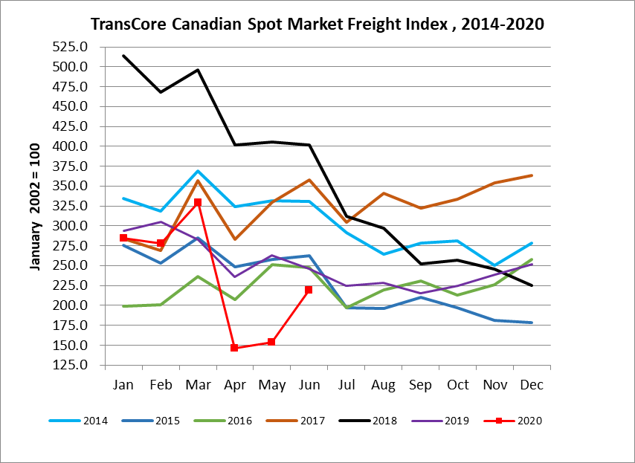

Loadlink Canadian Spot Market Truck Index 2014 - 2020
 | 2014 | 2015 | 2016 | 2017 | 2018 | 2019 | 2020 | Percent Change  Y-O-Y | Percent Change M-O-M
Jan | 104 | 112 | 144 | 136 | 99 | 170 | 173 | 2% | 8%
Feb | 95 | 110 | 157 | 130 | 90 | 149 | 153 | 3% | -11%
Mar | 99 | 127 | 164 | 145 | 104 | 179 | 163 | -9% | 7%
Apr | 108 | 142 | 164 | 130 | 121 | 203 | 188 | -7% | 15%
May | 112 | 140 | 163 | 152 | 141 | 214 | 184 | -14% | -2%
Jun | 111 | 151 | 170 | 142 | 133 | 186 | 191 | 3% | 4%
Jul | 125 | 166 | 162 | 137 | 158 | 213
Aug | 117 | 155 | 179 | 149 | 172 | 202
Sep | 122 | 158 | 163 | 132 | 154 | 191
Oct | 130 | 164 | 161 | 138 | 189 | 210
Nov | 115 | 159 | 163 | 130 | 179 | 186
Dec | 105 | 151 | 133 | 95 | 144 | 160

