Canadian Freight Index Highlights:

- Month-over-month: Volumes decreased 9 percent compared to January 2018.
- Year-over-year: Volumes increased 74 percent compared to February 2017.
- Highlights:
Loads: February load volumes were the second highest since Loadlink began recording data.
Equipment: This is the lowest volume recorded since 2006.
Truck-to-load ratio: Truckload capacity remained at less than one truck available for every load posted for February. It is the first time, since 2004, that two consecutive months have had the truck-to-load ratio fall below one.

Cross-Border: Cross-border load postings accounted for 76 percent of the data submitted by Loadlink’s Canadian-based customers.

- Inbound cross border loads (from the United States to Canada) increased 82 percent and outbound loads (from Canada to the US) increased 92 percent year-over-year.
- Inbound cross border equipment decreased 34 percent and outbound equipment decreased 34 percent year-over-year.

Cross Border Loads into Canada by Region of Destination:
Ontario: 60 percent
Western: 21 percent
Quebec: 18 percent
Atlantic: 1 percent

Cross Border Equipment into Canada by Region of Destination:
Ontario: 46 percent
Western: 30 percent
Quebec: 20 percent
Atlantic: 4 percent

Intra-Canada: Postings accounted for 22 percent of the data submitted by Loadlink’s Canadian-based customers.
Loads within Canada:
- By Region of Origin  Western: 48 percent  Ontario: 31 percent  Quebec: 18 percent  Atlantic: 3 percent | - By Region of Destination  Western: 40 percent  Ontario: 34 percent  Quebec: 22 percent  Atlantic: 4 percent

Equipment Breakdown: The top equipment postings were Dry Vans 52 percent, Reefers 22 percent, Flatbed 18 percent, and Other 8 percent.

TransCore Canadian Spot Market Freight Index 2012-2018
 | 2012 | 2013 | 2014 | 2015 | 2016 | 2017 | 2018 | Percent Change Y-O-Y | Percent Change M-O-M
Jan | 220 | 228 | 335 | 275 | 199 | 284 | 514 | 81% | 41%
Feb | 222 | 198 | 318 | 253 | 201 | 269 | 468 | 74% | -9%
Mar | 276 | 245 | 369 | 285 | 236 | 357
Apr | 266 | 229 | 324 | 249 | 207 | 283
May | 301 | 252 | 331 | 258 | 252 | 330
Jun | 295 | 234 | 331 | 263 | 247 | 358
Jul | 233 | 233 | 291 | 197 | 197 | 304
Aug | 235 | 229 | 264 | 196 | 220 | 341
Sep | 200 | 218 | 279 | 210 | 231 | 322
Oct | 215 | 232 | 282 | 197 | 213 | 333
Nov | 215 | 210 | 251 | 182 | 226 | 354
Dec | 182 | 234 | 278 | 178 | 258 | 364

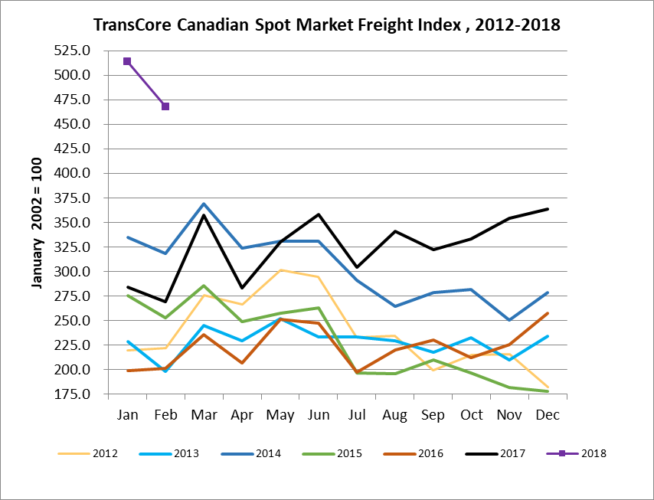
TransCore Canadian Spot Market Truck Index 2012-2018
 | 2012 | 2013 | 2014 | 2015 | 2016 | 2017 | 2018 | Percent Change  Y-O-Y | Percent Change M-O-M
Jan | 107 | 121 | 104 | 112 | 144 | 136 | 99 | -27% | 5%
Feb | 109 | 114 | 95 | 110 | 157 | 130 | 90 | -30% | -9%
Mar | 114 | 116 | 99 | 127 | 164 | 145
Apr | 110 | 123 | 108 | 142 | 164 | 130
May | 121 | 125 | 112 | 140 | 163 | 152
Jun | 112 | 126 | 111 | 151 | 170 | 142
Jul | 122 | 139 | 125 | 166 | 162 | 137
Aug | 126 | 134 | 117 | 155 | 179 | 149
Sep | 111 | 127 | 122 | 158 | 163 | 132
Oct | 134 | 139 | 130 | 164 | 161 | 138
Nov | 127 | 125 | 115 | 159 | 163 | 130
Dec | 104 | 105 | 105 | 151 | 133 | 95

