Canadian Freight Index Highlights:

- Month-over-month: Volumes increased five percent compared to November 2019.
- Year-over-year: Volumes increased 12 percent compared to December 2018.
- Highlights:
Truck-to-load ratio: The ratio contracted 19 percent to 2.78 from 3.43 in November. Year-over-year, the truck-to-load ratio dipped a single percentage point from a ratio of 2.82 trucks for every one load available in December 2018.

Load and Equipment Trend: As per the usual seasonal rush, December load volumes performed very well with numbers resembling those in mid-2018 when demand was at a healthier level. Declines in both truck and load availability were expected and seen at the end of December. Despite this late decline during the peak, holiday period, December’s overall load volumes surpassed November by five percent and beat December 2018 numbers by 12 percent.

Equipment volumes trended very similarly to 2018 but at higher levels for each month except February. Overall equipment volumes for the year were the highest in Loadlink’s history. This may be a result of additional capacity added to fleets following a busy 2018. With new truck orders fulfilled in late 2018 and early 2019, additional capacity was introduced during a year of reduced freight, causing more trucks to be available on the spot market. December’s equipment postings declined 14 percent when compared to November and increased 11 percent when compared to December 2018.

Cross-Border: Cross-border load postings accounted for 67 percent of the data submitted by Loadlink’s Canadian-based customers.

- Inbound cross-border loads (from the United States to Canada) decreased 13 percent and outbound loads (from Canada to the United States) increased 58 percent year-over-year.
- Inbound cross-border equipment increased 23 percent and outbound equipment decreased three percent year-over-year.
Cross-Border Loads into Canada by Region of Destination (with M-O-M volume change):
Ontario: | 56 percent | + 9%
Western: | 24 percent | + 25%
Quebec: | 18 percent | - 3%
Atlantic: | 2 percent | + 12%

Cross-Border Equipment into Canada by Region of Destination (with M-O-M volume change):
Ontario: | 50 percent | - 12%
Western: | 28 percent | - 17%
Quebec: | 18 percent | - 15%
Atlantic: | 4 percent | - 19%

Intra-Canada: Postings accounted for 32 percent of the data submitted by Loadlink’s Canadian-based customers.
Loads within Canada (with M-O-M volume change):

By Region of Origin |  |  | By Region of Destination
Ontario: | 33 percent | - 8% | Ontario: | 42 percent | - 2%
Western: | 44 percent | + 7% | Western: | 32 percent | + 4%
Quebec: | 19 percent | - 4% | Quebec: | 22 percent | - 1%
Atlantic: | 4 percent | - 14% | Atlantic: | 4 percent | - 32%

Equipment Breakdown: The top equipment postings were Dry Vans 53 percent, Reefers 25 percent, Flatbed 16 percent, and Other 6 percent.

TransCore Canadian Spot Market Freight Index 2013 - 2019
 | 2013 | 2014 | 2015 | 2016 | 2017 | 2018 | 2019 | Percent Change Y-O-Y | Percent Change M-O-M
Jan | 228 | 335 | 275 | 199 | 284 | 514 | 294 | -43% | 31%
Feb | 198 | 318 | 253 | 201 | 269 | 468 | 305 | -35% | 4%
Mar | 245 | 369 | 285 | 236 | 357 | 496 | 283 | -43% | -7%
Apr | 229 | 324 | 249 | 207 | 283 | 402 | 236 | -41% | -17%
May | 252 | 331 | 258 | 252 | 330 | 406 | 263 | -35% | 12%
Jun | 234 | 331 | 263 | 247 | 358 | 401 | 246 | -39% | -7%
Jul | 233 | 291 | 197 | 197 | 304 | 312 | 225 | -28% | -9%
Aug | 229 | 264 | 196 | 220 | 341 | 297 | 229 | -23% | 2%
Sep | 218 | 279 | 210 | 231 | 322 | 252 | 215 | -15% | -6%
Oct | 232 | 282 | 197 | 213 | 333 | 257 | 225 | -13% | 4%
Nov | 210 | 251 | 182 | 226 | 354 | 246 | 239 | -3% | 6%
Dec | 234 | 278 | 178 | 258 | 364 | 225 | 252 | 12% | 5%

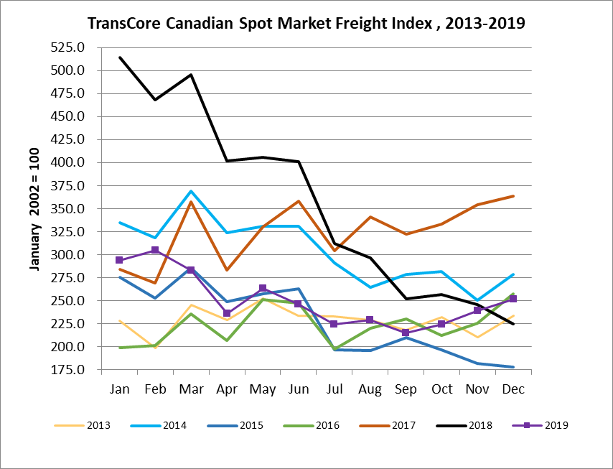

TransCore Canadian Spot Market Truck Index 2013 - 2019
 | 2013 | 2014 | 2015 | 2016 | 2017 | 2018 | 2019 | Percent Change  Y-O-Y | Percent Change M-O-M
Jan | 121 | 104 | 112 | 144 | 136 | 99 | 170 | 72% | 18%
Feb | 114 | 95 | 110 | 157 | 130 | 90 | 149 | 65% | -12%
Mar | 116 | 99 | 127 | 164 | 145 | 104 | 179 | 72% | 21%
Apr | 123 | 108 | 142 | 164 | 130 | 121 | 203 | 68% | 13%
May | 125 | 112 | 140 | 163 | 152 | 141 | 214 | 52% | 5%
Jun | 126 | 111 | 151 | 170 | 142 | 133 | 186 | 40% | -13%
Jul | 139 | 125 | 166 | 162 | 137 | 158 | 213 | 35% | 15%
Aug | 134 | 117 | 155 | 179 | 149 | 172 | 202 | 17% | -5%
Sep | 127 | 122 | 158 | 163 | 132 | 154 | 191 | 24% | -6%
Oct | 139 | 130 | 164 | 161 | 138 | 189 | 210 | 11% | 10%
Nov | 125 | 115 | 159 | 163 | 130 | 179 | 186 | 4% | -11%
Dec | 105 | 105 | 151 | 133 | 95 | 144 | 160 | 11% | -14%

