Canadian Freight Index Highlights:

- Month-over-month: Volumes decreased nine percent compared to November 2018.
- Year-over-year: Volumes decreased 38 percent compared to December 2017.
- Trends:
Loads: December load volumes ended the year as the lowest for 2018, in stark contrast to January’s highest load volumes recorded in Loadlink history.
- The year started with record-setting high load volumes and continued with strong performances for the first half of the year.
- Summer was welcomed alongside a new set of tariffs amidst international trade disputes, all of which caused a dramatic decrease in load volumes for the remainder of 2018.
- Year-over-year, the total load volumes averaged a 10 percent increase compared to the total average volumes in 2017.
Equipment: Truck capacity trended upwards throughout the year following a tight capacity crunch that began in December 2017 and lasted until April 2018.
- On average, truck volumes rose by four percent year-over-year. The smallest year-over-year percent change was in June at seven percent, while the highest percent change took place in December at 52 percent.
- The highest equipment volumes were in October and the lowest equipment volumes were in February.
Truck-to-load ratio: Truckload capacity was tight for the first half of 2018. Load volumes declined and truck volumes recovered during the latter half of the year, which caused capacity to expand.
- The ratio of trucks to loads began the year below a 1:1 ratio. As capacity recovered, it reached a high of over 3:1 near the year’s end. Overall, 2018 saw the number of trucks posted versus the number of loads posted closer to a healthy ratio of 2:1.
- The dynamic shift in capacity throughout 2018 was due to the coincidental polarity in load and truck volumes that occurred. While load volumes were at record highs at year start, truck availability was scarce. When truck availability began recovering, it coincided with when load volumes began dipping. This resulted in 2018 having both a capacity crunch and an expansion.
Cross-Border: Cross-border load postings accounted for 66 percent of the data submitted by Loadlink’s customers.

- Inbound cross border loads (from the United States to Canada) decreased 38 percent and outbound loads (from Canada to the US) decreased 52 percent year-over-year.
- Inbound cross border equipment increased 45 percent and outbound equipment increased 73 percent year-over-year.
Cross Border Loads into Canada by Region of Destination:
Ontario: 55 percent
Western: 23 percent
Quebec: 20 percent
Atlantic: 2 percent

Cross Border Equipment into Canada by Region of Destination:
Ontario: 49 percent
Western: 30 percent
Quebec: 18 percent
Atlantic: 3 percent

Intra-Canada: Postings accounted for 32 percent of the data submitted by Loadlink’s customers.
Loads within Canada:
- By Region of Origin  Western: 43 percent  Ontario: 33 percent  Quebec: 19 percent  Atlantic: 5 percent | - By Region of Destination  Western: 35 percent  Ontario: 40 percent  Quebec: 21 percent  Atlantic: 4 percent

Equipment Breakdown: The top equipment postings were Dry Vans 53 percent, Reefers 25 percent, Flatbed 17 percent, and Other 5 percent.

TransCore Canadian Spot Market Freight Index 2012-2018
 | 2012 | 2013 | 2014 | 2015 | 2016 | 2017 | 2018 | Percent Change Y-O-Y | Percent Change M-O-M
Jan | 220 | 228 | 335 | 275 | 199 | 284 | 514 | 81% | 41%
Feb | 222 | 198 | 318 | 253 | 201 | 269 | 468 | 74% | -9%
Mar | 276 | 245 | 369 | 285 | 236 | 357 | 496 | 39% | 6%
Apr | 266 | 229 | 324 | 249 | 207 | 283 | 402 | 42% | -19%
May | 301 | 252 | 331 | 258 | 252 | 330 | 406 | 23% | 1%
Jun | 295 | 234 | 331 | 263 | 247 | 358 | 401 | 12% | -1%
Jul | 233 | 233 | 291 | 197 | 197 | 304 | 312 | 3% | -22%
Aug | 235 | 229 | 264 | 196 | 220 | 341 | 297 | -13% | -5%
Sep | 200 | 218 | 279 | 210 | 231 | 322 | 252 | -22% | -15%
Oct | 215 | 232 | 282 | 197 | 213 | 333 | 257 | -23% | 2%
Nov | 215 | 210 | 251 | 182 | 226 | 354 | 246 | -31% | -4%
Dec | 182 | 234 | 278 | 178 | 258 | 364 | 225 | -38% | -9%

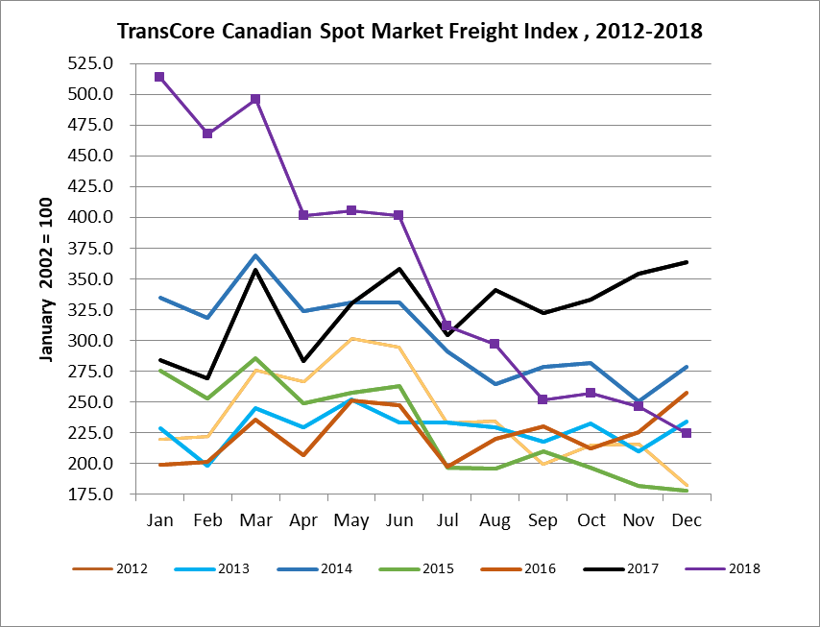

TransCore Canadian Spot Market Truck Index 2012-2018
 | 2012 | 2013 | 2014 | 2015 | 2016 | 2017 | 2018 | Percent Change  Y-O-Y | Percent Change M-O-M
Jan | 107 | 121 | 104 | 112 | 144 | 136 | 99 | -27% | 5%
Feb | 109 | 114 | 95 | 110 | 157 | 130 | 90 | -30% | -9%
Mar | 114 | 116 | 99 | 127 | 164 | 145 | 104 | -28% | 15%
Apr | 110 | 123 | 108 | 142 | 164 | 130 | 121 | -7% | 16%
May | 121 | 125 | 112 | 140 | 163 | 152 | 141 | -7% | 17%
Jun | 112 | 126 | 111 | 151 | 170 | 142 | 133 | -7% | -6%
Jul | 122 | 139 | 125 | 166 | 162 | 137 | 158 | 15% | 19%
Aug | 126 | 134 | 117 | 155 | 179 | 149 | 172 | 15% | 9%
Sep | 111 | 127 | 122 | 158 | 163 | 132 | 154 | 16% | -11%
Oct | 134 | 139 | 130 | 164 | 161 | 138 | 189 | 36% | 22%
Nov | 127 | 125 | 115 | 159 | 163 | 130 | 179 | 38% | -5%
Dec | 104 | 105 | 105 | 151 | 133 | 95 | 144 | 52% | -20%

