Canadian Freight Index Highlights:

- Month-over-month: Volumes increased three percent compared to November 2017.
- Year-over-year: Volumes increased 41 percent compared to December 2016.
- Trends:
Loads: December load volumes was the highest for 2017, and the second highest since Loadlink began recording data.
- The year started with promisingly high load volumes and continued that way for the first half of the year. May was the first month when volumes started to trend higher than any other recorded volumes and they continued that way until the end of 2017.
- The trend in the latter half of the year was the first trend of this type.
- Year-over-year, the total load volumes averaged a 45 percent increase compared to the total average volumes in 2016.
Equipment: Truck capacity trended lower compared to the previous year.
- On average, truck volumes declined by 16 percent year-over-year. The smallest percent change was in January 2017 at six percent, while the highest year-over-year percent change took place in December at 29 percent.
- The highest equipment volumes were in May and the lowest equipment volumes were in December.
Truck-to-load ratio: Truckload capacity in 2017 was tight. A similar market with tightened truckload capacity of this type was last seen in 2014.
- Overall, 2017 saw the number of trucks posted versus the number of loads posted near a 2:1 ratio for the first time in eight months, dipping incrementally in months nine to 11, before closing close to a 1:1 ratio in December.
- The tightened capacity was primarily driven by the growth in load volumes.
Cross-Border: Cross-border load postings accounted for 73 percent of the data submitted by Loadlink’s Canadian-based customers.

- Inbound cross border loads (from the United States to Canada) increased 53 percent and outbound loads (from Canada to the US) increased 53 percent year-over-year.
- Inbound cross border equipment decreased 30 percent and outbound equipment decreased 34 percent year-over-year.
Cross Border Loads into Canada by Region of Destination:
Ontario: 56 percent
Western: 25 percent
Quebec: 18 percent
Atlantic: 1 percent

Cross Border Equipment into Canada by Region of Destination:
Ontario: 49 percent
Western: 26 percent
Quebec: 21 percent
Atlantic: 4 percent

Intra-Canada: Postings accounted for 24 percent of the data submitted by Loadlink’s Canadian-based customers.
Loads within Canada:
- By Region of Origin  Western: 43 percent  Ontario: 31 percent  Quebec: 22 percent  Atlantic: 4 percent | - By Region of Destination  Western: 34 percent  Ontario: 41 percent  Quebec: 21 percent  Atlantic: 4 percent

Equipment Breakdown: The top equipment postings were Dry Vans 52 percent, Reefers 21 percent, Flatbed 20 percent, and Other 7 percent.

TransCore Canadian Spot Market Freight Index 2011-2017
 | 2011 | 2012 | 2013 | 2014 | 2015 | 2016 | 2017 | Percent Change Y-O-Y | Percent Change M-O-M
Jan | 222 | 220 | 228 | 335 | 275 | 199 | 284 | 43% | 10%
Feb | 248 | 222 | 198 | 318 | 253 | 201 | 269 | 34% | -5%
Mar | 337 | 276 | 245 | 369 | 285 | 236 | 357 | 51% | 33%
Apr | 300 | 266 | 229 | 324 | 249 | 207 | 283 | 37% | -21%
May | 307 | 301 | 252 | 331 | 258 | 252 | 330 | 31% | 17%
Jun | 315 | 295 | 234 | 331 | 263 | 247 | 358 | 45% | 9%
Jul | 245 | 233 | 233 | 291 | 197 | 197 | 304 | 54% | -15%
Aug | 270 | 235 | 229 | 264 | 196 | 220 | 341 | 55% | 12%
Sep | 263 | 200 | 218 | 279 | 210 | 231 | 322 | 40% | -6%
Oct | 251 | 215 | 232 | 282 | 197 | 213 | 333 | 57% | 3%
Nov | 252 | 215 | 210 | 251 | 182 | 226 | 354 | 57% | 6%
Dec | 217 | 182 | 234 | 278 | 178 | 258 | 364 | 41% | 3%

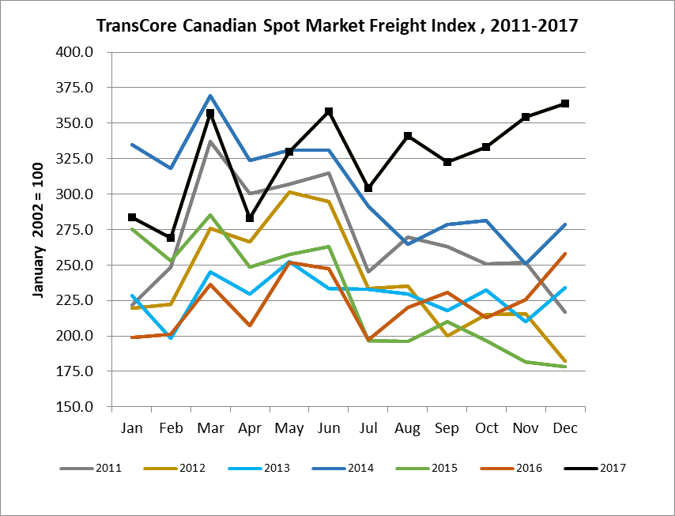

TransCore Canadian Spot Market Truck Index 2011-2017
 | 2011 | 2012 | 2013 | 2014 | 2015 | 2016 | 2017 | Percent Change  Y-O-Y | Percent Change M-O-M
Jan | 105 | 107 | 121 | 104 | 112 | 144 | 136 | -6% | 2%
Feb | 94 | 109 | 114 | 95 | 110 | 157 | 130 | -17% | -4%
Mar | 104 | 114 | 116 | 99 | 127 | 164 | 145 | -12% | 11%
Apr | 93 | 110 | 123 | 108 | 142 | 164 | 130 | -21% | -10%
May | 105 | 121 | 125 | 112 | 140 | 163 | 152 | -7% | -17%
Jun | 107 | 112 | 126 | 111 | 151 | 170 | 142 | -16% | -6%
Jul | 100 | 122 | 139 | 125 | 166 | 162 | 137 | -16% | -4%
Aug | 112 | 126 | 134 | 117 | 155 | 179 | 149 | -17% | 9%
Sep | 105 | 111 | 127 | 122 | 158 | 163 | 132 | -19% | -11%
Oct | 103 | 134 | 139 | 130 | 164 | 161 | 138 | -14% | 5%
Nov | 109 | 127 | 125 | 115 | 159 | 163 | 130 | -20% | -6%
Dec | 97 | 104 | 105 | 105 | 151 | 133 | 95 | -29% | -27%

