Canadian Freight Index Highlights:

- Month-over-month: Volumes increased 12 percent compared to April 2019.
- Year-over-year: Volumes decreased 35 percent compared to May 2018.
- Highlights:
Truck-to-load ratio: The ratio decreased five percent to 3.57 from 3.78 in April 2019. Year-over-year, May’s truck-to-load ratio increased 134 percent compared to 1.52 trucks for every one load available recorded in May 2018.

Load and Equipment Trend: For the month of May, the average daily truck postings increased just one percent, while daily load postings rebounded upwards six percent. An overall increase of five percent in total truck postings resulted in another record month for highest truck volumes recorded in Loadlink’s database.

As forecasted last month, May load volumes recovered from expectedly lower April numbers. June load volumes have generally followed May values closely, with the average change in load volumes between June and May from 2002 to 2018 being a one percentage point increase month-over-month (compared to an average 12 percent increase from April to May between the same time frame).

Cross-Border: Cross-border load postings accounted for 66 percent of the data submitted by Loadlink’s Canadian-based customers.

- Inbound cross border loads (from the United States to Canada) decreased 34 percent and outbound loads (from Canada to the U.S.) decreased 47 percent year-over-year.
- Inbound cross border equipment increased 50 percent and outbound equipment increased 53 percent year-over-year.

Cross Border Loads into Canada by Region of Destination (with M-O-M volume change):
Ontario: 57 percent | + 28%
Western: 17 percent | - 8%
Quebec: 23 percent | + 27%
Atlantic: 3 percent | + 18%

Cross Border Equipment into Canada by Region of Destination (with M-O-M volume change):
Ontario: 46 percent | - 3%
Western: 34 percent | + 8%
Quebec: 16 percent | - 8%
Atlantic: 4 percent | - 2%

Intra-Canada: Postings accounted for 32 percent of the data submitted by Loadlink’s Canadian-based customers.

Loads within Canada (with M-O-M volume change):

By Region of Origin |  | By Region of Destination
Ontario: 34 percent | + 9% | Ontario: 41 percent | + 12%
Western: 34 percent | + 3% | Western: 30 percent | + 15%
Quebec: 25 percent | + 19% | Quebec: 25 percent | + 10%
Atlantic: 7 percent | + 31% | Atlantic: 4 percent | - 20%

Equipment Breakdown: The top equipment postings were Dry Vans 52 percent, Reefers 26 percent, Flatbed 15 percent, and Other 7 percent.

TransCore Canadian Spot Market Freight Index 2013 - 2019
 | 2013 | 2014 | 2015 | 2016 | 2017 | 2018 | 2019 | Percent Change Y-O-Y | Percent Change M-O-M
Jan | 228 | 335 | 275 | 199 | 284 | 514 | 294 | -43% | 31%
Feb | 198 | 318 | 253 | 201 | 269 | 468 | 305 | -35% | 4%
Mar | 245 | 369 | 285 | 236 | 357 | 496 | 283 | -43% | -7%
Apr | 229 | 324 | 249 | 207 | 283 | 402 | 236 | -41% | -17%
May | 252 | 331 | 258 | 252 | 330 | 406 | 263 | -35% | 12%
Jun | 234 | 331 | 263 | 247 | 358 | 401
Jul | 233 | 291 | 197 | 197 | 304 | 312
Aug | 229 | 264 | 196 | 220 | 341 | 297
Sep | 218 | 279 | 210 | 231 | 322 | 252
Oct | 232 | 282 | 197 | 213 | 333 | 257
Nov | 210 | 251 | 182 | 226 | 354 | 246
Dec | 234 | 278 | 178 | 258 | 364 | 225

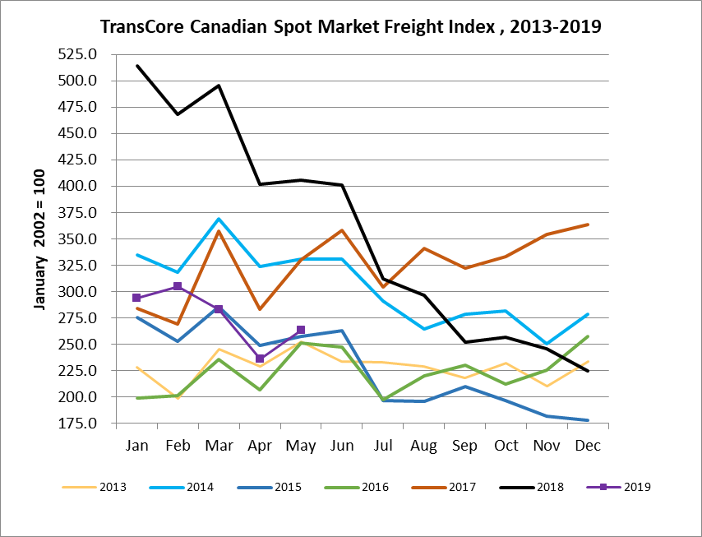

TransCore Canadian Spot Market Truck Index 2013 - 2019
 | 2013 | 2014 | 2015 | 2016 | 2017 | 2018 | 2019 | Percent Change  Y-O-Y | Percent Change M-O-M
Jan | 121 | 104 | 112 | 144 | 136 | 99 | 170 | 72% | 18%
Feb | 114 | 95 | 110 | 157 | 130 | 90 | 149 | 65% | -12%
Mar | 116 | 99 | 127 | 164 | 145 | 104 | 179 | 72% | 21%
Apr | 123 | 108 | 142 | 164 | 130 | 121 | 203 | 68% | 13%
May | 125 | 112 | 140 | 163 | 152 | 141 | 214 | 52% | 5%
Jun | 126 | 111 | 151 | 170 | 142 | 133
Jul | 139 | 125 | 166 | 162 | 137 | 158
Aug | 134 | 117 | 155 | 179 | 149 | 172
Sep | 127 | 122 | 158 | 163 | 132 | 154
Oct | 139 | 130 | 164 | 161 | 138 | 189
Nov | 125 | 115 | 159 | 163 | 130 | 179
Dec | 105 | 105 | 151 | 133 | 95 | 144

