Canadian Freight Index Highlights:

- Month-over-month: Volumes decreased seven percent compared to February 2019.
- Year-over-year: Volumes decreased 43 percent compared to March 2018.
- Quarterly Highlights:
  - Freight Volumes: Load volumes for Q1 2019 were up 21 percent compared to Q4 2018, but were down 40 percent from Q1 2018’s historic numbers.
  - Truck Capacity: Truck volumes for Q1 2019 were down three percent compared to Q4 2018, but were up 70 percent year-over-year following early 2018’s capacity crunch.
  - Truck-to-load ratio: Truckload capacity decreased 20 percent to 2.48 from 3.09 in Q4 2018. This is almost identical to Q3 2018’s value of 2.47. Year-over-year, the Q1 truck-to-load ratio increased 184 percent from the low ratio of 0.85 trucks for every one load available in Q1 2018. March 2019’s truck-to-load ratio was 2.79.

Load and Equipment Trend: Average daily load postings took a step down from February, dropping 16 percent, while daily truck postings saw a significant gain of 21 percent. March 2019 was the first time in Loadlink’s history where March load volumes were below those of the February preceding it.

Cross-Border: Cross-border load postings accounted for 65 percent of the data submitted by Loadlink’s Canadian-based customers.

- Inbound cross border loads (from the United States to Canada) decreased 48 percent and outbound loads (from Canada to the U.S.) decreased 53 percent year-over-year.
- Inbound cross border equipment increased 88 percent and outbound equipment increased 76 percent year-over-year.

Cross Border Loads into Canada by Region of Destination (with M-O-M volume change):
Ontario: 58 percent | - 17%
Western: 21 percent | + 16%
Quebec: 19 percent | - 7%
Atlantic: 2 percent | + 18%

Cross Border Equipment into Canada by Region of Destination (with M-O-M volume change):
Ontario: 46 percent | + 22%
Western: 34 percent | + 11%
Quebec: 16 percent | + 17%
Atlantic: 4 percent | + 7%

Intra-Canada: Postings accounted for 33 percent of the data submitted by Loadlink’s Canadian-based customers.

Loads within Canada (with M-O-M volume change):

By Region of Origin |  | By Region of Destination
Western: 44 percent | + 1% | Western: 31 percent | + 2%
Ontario: 32 percent | - 11% | Ontario: 40 percent | - 6%
Quebec: 19 percent | - 7% | Quebec: 24 percent | - 11%
Atlantic: 5 percent | + 44% | Atlantic: 5 percent | + 30%

Equipment Breakdown: The top equipment postings were Dry Vans 54 percent, Reefers 25 percent, Flatbed 15 percent, and Other 6 percent.

TransCore Canadian Spot Market Freight Index 2013 - 2019
 | 2013 | 2014 | 2015 | 2016 | 2017 | 2018 | 2019 | Percent Change Y-O-Y | Percent Change M-O-M
Jan | 228 | 335 | 275 | 199 | 284 | 514 | 294 | -43% | 31%
Feb | 198 | 318 | 253 | 201 | 269 | 468 | 305 | -35% | 4%
Mar | 245 | 369 | 285 | 236 | 357 | 496 | 283 | -43% | -7%
Apr | 229 | 324 | 249 | 207 | 283 | 402
May | 252 | 331 | 258 | 252 | 330 | 406
Jun | 234 | 331 | 263 | 247 | 358 | 401
Jul | 233 | 291 | 197 | 197 | 304 | 312
Aug | 229 | 264 | 196 | 220 | 341 | 297
Sep | 218 | 279 | 210 | 231 | 322 | 252
Oct | 232 | 282 | 197 | 213 | 333 | 257
Nov | 210 | 251 | 182 | 226 | 354 | 246
Dec | 234 | 278 | 178 | 258 | 364 | 225

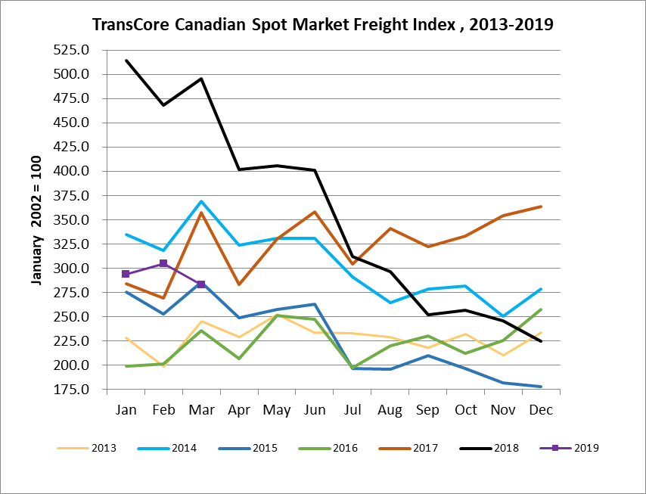

TransCore Canadian Spot Market Truck Index 2013 - 2019
 | 2013 | 2014 | 2015 | 2016 | 2017 | 2018 | 2019 | Percent Change  Y-O-Y | Percent Change M-O-M
Jan | 121 | 104 | 112 | 144 | 136 | 99 | 170 | 72% | 18%
Feb | 114 | 95 | 110 | 157 | 130 | 90 | 149 | 65% | -12%
Mar | 116 | 99 | 127 | 164 | 145 | 104 | 179 | 72% | 21%
Apr | 123 | 108 | 142 | 164 | 130 | 121
May | 125 | 112 | 140 | 163 | 152 | 141
Jun | 126 | 111 | 151 | 170 | 142 | 133
Jul | 139 | 125 | 166 | 162 | 137 | 158
Aug | 134 | 117 | 155 | 179 | 149 | 172
Sep | 127 | 122 | 158 | 163 | 132 | 154
Oct | 139 | 130 | 164 | 161 | 138 | 189
Nov | 125 | 115 | 159 | 163 | 130 | 179
Dec | 105 | 105 | 151 | 133 | 95 | 144

