Canadian Freight Index Highlights:

- Month-over-month: Volumes increased 31 percent compared to December 2018.
- Year-over-year: Volumes decreased 43 percent compared to January 2018.
- Highlights:
Truck-to-load ratio: Truckload capacity decreased 10 percent to 2.54 from 2.82 in December 2018. This is the lowest ratio since August 2018 when the ratio was 2.55. Year-over-year, January’s truck-to-load ratio is a 200 percent increase from January 2018’s extremely low ratio of 0.85 trucks for every load available.

- Load & Equipment trend: Both equipment and load volumes in January very closely resembled those in August 2018, with only a one percentage point difference between either numbers.

Cross-Border: Cross-border load postings accounted for 71 percent of the data submitted by Loadlink’s Canadian-based customers.

- Inbound cross border loads (from the United States to Canada) decreased 42 percent and outbound loads (from Canada to the U.S.) decreased 58 percent year-over-year.
- Inbound cross border equipment increased 65 percent and outbound equipment increased 97 percent year-over-year.

Cross Border Loads into Canada by Region of Destination (with M-O-M change):
Ontario: 60 percent | + 5%
Western: 17 percent | - 6%
Quebec: 21 percent | + 1%
Atlantic: 2 percent | 0%

Cross Border Equipment into Canada by Region of Destination (with M-O-M change):
Ontario: 46 percent | - 3%
Western: 34 percent | + 4%
Quebec: 16 percent | - 2%
Atlantic: 4 percent | + 1%

Intra-Canada: Postings accounted for 27 percent of the data submitted by Loadlink’s Canadian-based customers.
Loads within Canada (with M-O-M change):

By Region of Origin |  | By Region of Destination
Western: 42 percent | - 1% | Western: 36 percent | + 1%
Ontario: 34 percent | + 1% | Ontario: 38 percent | - 2%
Quebec: 20 percent | + 1% | Quebec: 21 percent | 0%
Atlantic: 4 percent | - 1% | Atlantic: 5 percent | - 1%

Equipment Breakdown: The top equipment postings were Dry Vans 53 percent, Reefers 25 percent, Flatbed 17 percent, and Other 5 percent.

TransCore Canadian Spot Market Freight Index 2013 - 2019
 | 2013 | 2014 | 2015 | 2016 | 2017 | 2018 | 2019 | Percent Change Y-O-Y | Percent Change M-O-M
Jan | 228 | 335 | 275 | 199 | 284 | 514 | 294 | -43% | 31%
Feb | 198 | 318 | 253 | 201 | 269 | 468
Mar | 245 | 369 | 285 | 236 | 357 | 496
Apr | 229 | 324 | 249 | 207 | 283 | 402
May | 252 | 331 | 258 | 252 | 330 | 406
Jun | 234 | 331 | 263 | 247 | 358 | 401
Jul | 233 | 291 | 197 | 197 | 304 | 312
Aug | 229 | 264 | 196 | 220 | 341 | 297
Sep | 218 | 279 | 210 | 231 | 322 | 252
Oct | 232 | 282 | 197 | 213 | 333 | 257
Nov | 210 | 251 | 182 | 226 | 354 | 246
Dec | 234 | 278 | 178 | 258 | 364 | 225

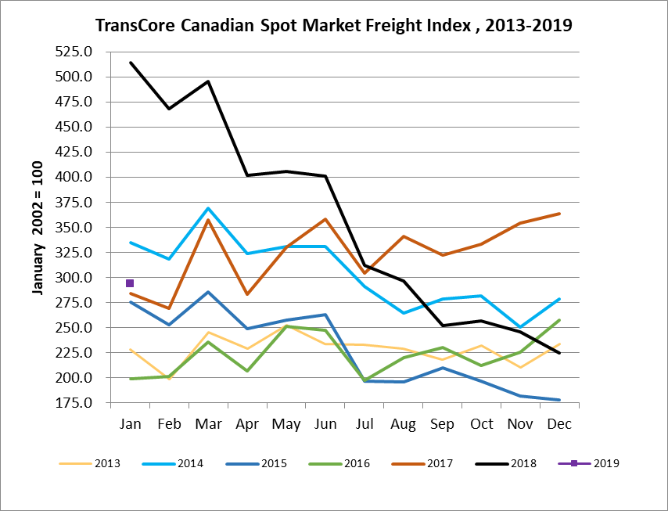

TransCore Canadian Spot Market Truck Index 2013 - 2019
 | 2013 | 2014 | 2015 | 2016 | 2017 | 2018 | 2019 | Percent Change  Y-O-Y | Percent Change M-O-M
Jan | 121 | 104 | 112 | 144 | 136 | 99 | 170 | 72% | 18%
Feb | 114 | 95 | 110 | 157 | 130 | 90
Mar | 116 | 99 | 127 | 164 | 145 | 104
Apr | 123 | 108 | 142 | 164 | 130 | 121
May | 125 | 112 | 140 | 163 | 152 | 141
Jun | 126 | 111 | 151 | 170 | 142 | 133
Jul | 139 | 125 | 166 | 162 | 137 | 158
Aug | 134 | 117 | 155 | 179 | 149 | 172
Sep | 127 | 122 | 158 | 163 | 132 | 154
Oct | 139 | 130 | 164 | 161 | 138 | 189
Nov | 125 | 115 | 159 | 163 | 130 | 179
Dec | 105 | 105 | 151 | 133 | 95 | 144

