Canadian Freight Index Highlights:

- Month-over-month: Volumes increased two percent compared to July 2019.
- Year-over-year: Volumes decreased 23 percent compared to August 2018.
- Highlights:
Truck-to-load ratio: The ratio decreased seven percent to 3.88 from 4.16 in July 2019. Year-over-year, August’s truck-to-load ratio increased 52 percent compared to 2.55 trucks for every one load available recorded in August 2018.

Load and Equipment Trend: In August, average daily load postings increased seven percent, while average daily truck postings slid by under one percent. An overall decrease of five percent in truck volumes, and a slight uptick in load volumes for the month resulted in truckload balance tipping slightly in favour of carriers.
Daily volumes in the month remained relatively consistent, barring a boost at the end of the month. This could have coincided with the long weekend, some last minute back-to-school shipments, as well as from emergency relief shipments in preparation for Hurricane Dorian.

Hurricane-related at-risk markets in Florida and parts of Georgia saw average inbound load volumes increase 37 percent in the days preceding the storm reaching the coast of the United States. Average inbound truck volumes dropped eight percent, as carriers may have wanted to avoid positioning equipment in these areas prior to the hurricane.

Cross-Border: Cross-border load postings accounted for 63 percent of the data submitted by Loadlink’s Canadian-based customers.

- Inbound cross-border loads (from the United States to Canada) decreased 26 percent and outbound loads (from Canada to the U.S.) decreased 24 percent year-over-year.
- Inbound cross-border equipment increased 19 percent and outbound equipment increased 16 percent year-over-year.

Cross-Border Loads into Canada by Region of Destination (with M-O-M volume change):
Ontario: 55 percent | - 15%
Western: 21 percent | - 1%
Quebec: 22 percent | - 9%
Atlantic: 2 percent | - 14%

Cross-Border Equipment into Canada by Region of Destination (with M-O-M volume change):
Ontario: 49 percent | - 6%
Western: 31 percent | + 7%
Quebec: 16 percent | + 3%
Atlantic: 4 percent | - 6%

Intra-Canada: Postings accounted for 35 percent of the data submitted by Loadlink’s Canadian-based customers.

Loads within Canada (with M-O-M volume change):

By Region of Origin |  | By Region of Destination
Ontario: 37 percent | - 1% | Ontario: 44 percent | - 7%
Western: 33 percent | - 1% | Western: 29 percent | + 19%
Quebec: 23 percent | + 7% | Quebec: 24 percent | - 14%
Atlantic: 7 percent | - 1% | Atlantic: 3 percent | - 7%

Equipment Breakdown: The top equipment postings were Dry Vans 52 percent, Reefers 27 percent, Flatbed 16 percent, and Other 5 percent.

TransCore Canadian Spot Market Freight Index 2013 - 2019
 | 2013 | 2014 | 2015 | 2016 | 2017 | 2018 | 2019 | Percent Change Y-O-Y | Percent Change M-O-M
Jan | 228 | 335 | 275 | 199 | 284 | 514 | 294 | -43% | 31%
Feb | 198 | 318 | 253 | 201 | 269 | 468 | 305 | -35% | 4%
Mar | 245 | 369 | 285 | 236 | 357 | 496 | 283 | -43% | -7%
Apr | 229 | 324 | 249 | 207 | 283 | 402 | 236 | -41% | -17%
May | 252 | 331 | 258 | 252 | 330 | 406 | 263 | -35% | 12%
Jun | 234 | 331 | 263 | 247 | 358 | 401 | 246 | -39% | -7%
Jul | 233 | 291 | 197 | 197 | 304 | 312 | 225 | -28% | -9%
Aug | 229 | 264 | 196 | 220 | 341 | 297 | 229 | -23% | 2%
Sep | 218 | 279 | 210 | 231 | 322 | 252
Oct | 232 | 282 | 197 | 213 | 333 | 257
Nov | 210 | 251 | 182 | 226 | 354 | 246
Dec | 234 | 278 | 178 | 258 | 364 | 225

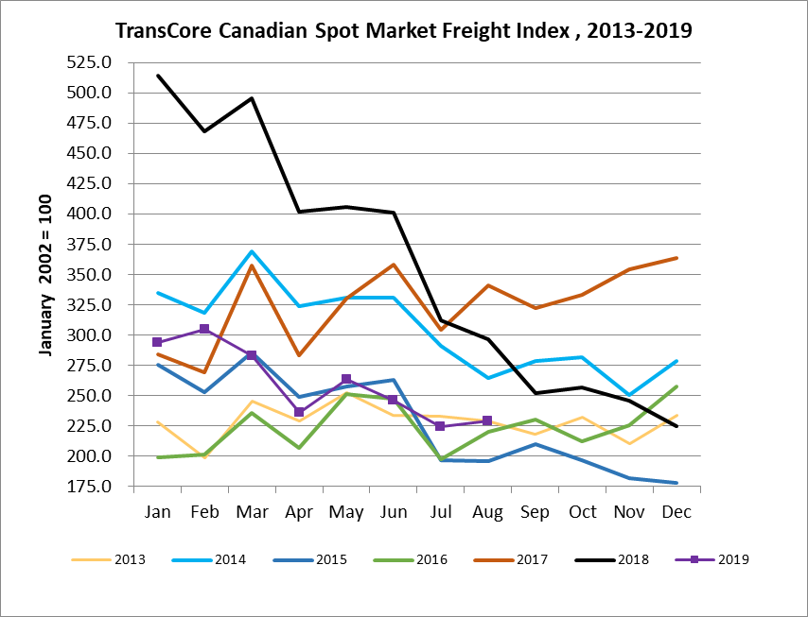

TransCore Canadian Spot Market Truck Index 2013 - 2019
 | 2013 | 2014 | 2015 | 2016 | 2017 | 2018 | 2019 | Percent Change  Y-O-Y | Percent Change M-O-M
Jan | 121 | 104 | 112 | 144 | 136 | 99 | 170 | 72% | 18%
Feb | 114 | 95 | 110 | 157 | 130 | 90 | 149 | 65% | -12%
Mar | 116 | 99 | 127 | 164 | 145 | 104 | 179 | 72% | 21%
Apr | 123 | 108 | 142 | 164 | 130 | 121 | 203 | 68% | 13%
May | 125 | 112 | 140 | 163 | 152 | 141 | 214 | 52% | 5%
Jun | 126 | 111 | 151 | 170 | 142 | 133 | 186 | 40% | -13%
Jul | 139 | 125 | 166 | 162 | 137 | 158 | 213 | 35% | 15%
Aug | 134 | 117 | 155 | 179 | 149 | 172 | 202 | 17% | -5%
Sep | 127 | 122 | 158 | 163 | 132 | 154
Oct | 139 | 130 | 164 | 161 | 138 | 189
Nov | 125 | 115 | 159 | 163 | 130 | 179
Dec | 105 | 105 | 151 | 133 | 95 | 144

