Canadian Freight Index Highlights:

- Month-over-month: Volumes decreased 17 percent compared to March 2019.
- Year-over-year: Volumes decreased 41 percent compared to April 2018.
- Highlights:
Truck-to-load ratio: Truckload capacity increased 36 percent to 3.78 from 2.79 in March 2019. This is the highest ratio since November 2015 when the ratio was 3.84. Year-over-year, April’s truck-to-load ratio increased 185 percent compared to 1.32 trucks for every one load available recorded in April 2018.

Load and Equipment Trend: Average daily truck postings increased 13 percent, while daily load postings declined 17 percent. Truck posting numbers set a new record in April, displaying the highest number ever recorded in Loadlink’s database. April usually sees a decrease in load postings from March, while the seasonal effect generally offers increases into the rest of Q2.

Cross-Border: Cross-border load postings accounted for 65 percent of the data submitted by Loadlink’s Canadian-based customers.

- Inbound cross border loads (from the United States to Canada) decreased 43 percent and outbound loads (from Canada to the U.S.) decreased 52 percent year-over-year.
- Inbound cross border equipment increased 71 percent and outbound equipment increased 70 percent year-over-year.

Cross Border Loads into Canada by Region of Destination (with M-O-M volume change):
Ontario: 54 percent | - 10%
Western: 22 percent | - 26%
Quebec: 22 percent | - 2%
Atlantic: 2 percent | - 6%

Cross Border Equipment into Canada by Region of Destination (with M-O-M volume change):
Ontario: 47 percent | + 20%
Western: 31 percent | + 9%
Quebec: 18 percent | + 7%
Atlantic: 4 percent | + 15%

Intra-Canada: Postings accounted for 33 percent of the data submitted by Loadlink’s Canadian-based customers.
Loads within Canada (with M-O-M volume change):

By Region of Origin |  | By Region of Destination
Western: 36 percent | - 32% | Western: 29 percent | - 22%
Ontario: 34 percent | - 12% | Ontario: 40 percent | - 18%
Quebec: 24 percent | + 2% | Quebec: 25 percent | - 16%
Atlantic: 6 percent | - 12% | Atlantic: 6 percent | - 10%

Equipment Breakdown: The top equipment postings were Dry Vans 53 percent, Reefers 25 percent, Flatbed 16 percent, and Other 6 percent.

TransCore Canadian Spot Market Freight Index 2013 - 2019
 | 2013 | 2014 | 2015 | 2016 | 2017 | 2018 | 2019 | Percent Change Y-O-Y | Percent Change M-O-M
Jan | 228 | 335 | 275 | 199 | 284 | 514 | 294 | -43% | 31%
Feb | 198 | 318 | 253 | 201 | 269 | 468 | 305 | -35% | 4%
Mar | 245 | 369 | 285 | 236 | 357 | 496 | 283 | -43% | -7%
Apr | 229 | 324 | 249 | 207 | 283 | 402 | 236 | -41% | -17%
May | 252 | 331 | 258 | 252 | 330 | 406
Jun | 234 | 331 | 263 | 247 | 358 | 401
Jul | 233 | 291 | 197 | 197 | 304 | 312
Aug | 229 | 264 | 196 | 220 | 341 | 297
Sep | 218 | 279 | 210 | 231 | 322 | 252
Oct | 232 | 282 | 197 | 213 | 333 | 257
Nov | 210 | 251 | 182 | 226 | 354 | 246
Dec | 234 | 278 | 178 | 258 | 364 | 225

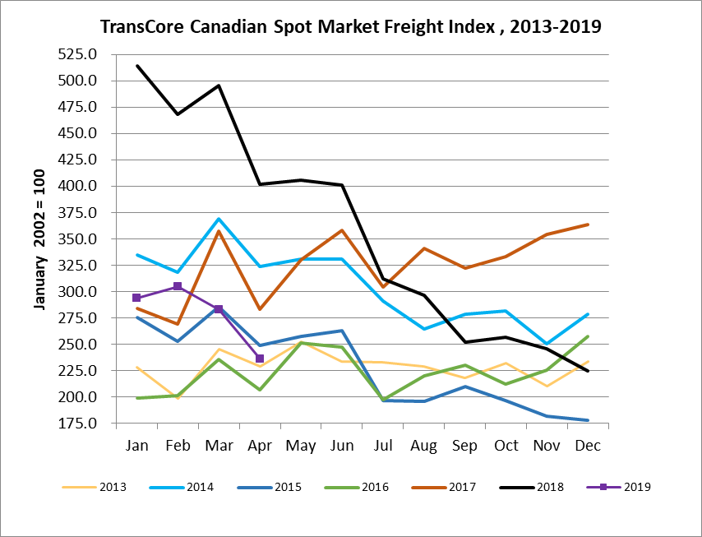

TransCore Canadian Spot Market Truck Index 2013 - 2019
 | 2013 | 2014 | 2015 | 2016 | 2017 | 2018 | 2019 | Percent Change  Y-O-Y | Percent Change M-O-M
Jan | 121 | 104 | 112 | 144 | 136 | 99 | 170 | 72% | 18%
Feb | 114 | 95 | 110 | 157 | 130 | 90 | 149 | 65% | -12%
Mar | 116 | 99 | 127 | 164 | 145 | 104 | 179 | 72% | 21%
Apr | 123 | 108 | 142 | 164 | 130 | 121 | 203 | 68% | 13%
May | 125 | 112 | 140 | 163 | 152 | 141
Jun | 126 | 111 | 151 | 170 | 142 | 133
Jul | 139 | 125 | 166 | 162 | 137 | 158
Aug | 134 | 117 | 155 | 179 | 149 | 172
Sep | 127 | 122 | 158 | 163 | 132 | 154
Oct | 139 | 130 | 164 | 161 | 138 | 189
Nov | 125 | 115 | 159 | 163 | 130 | 179
Dec | 105 | 105 | 151 | 133 | 95 | 144

