Canadian Freight Index Highlights:

- Month-over-month: Volumes decreased six percent compared to August 2019.
- Year-over-year: Volumes decreased 15 percent compared to September 2018.
- Quarterly Highlights:
  - Freight Volumes: Load volumes for Q3 2019 were down 10 percent compared to Q2 2019, and were down 22 percent compared to the same period last year.
  - Truck Capacity: Truck volumes for Q3 2019 were up one percent compared to Q2 2019, and were up 25 percent year-over-year. Month-over-month, truck volumes decreased six percent in September.
  - Truck-to-load ratio: The ratio expanded 12 percent to 3.98 from 3.55 in Q2 2019. Year-over-year, the Q3 truck-to-load ratio increased 60 percent from a ratio of 2.48 trucks for every one load available in Q3 2018. Month-over-month, the ratio increased less than a single percentage point to 3.90 from 3.88 in August 2019. Year-over-year, September’s truck-to-load ratio increased 45 percent compared to 2.55 trucks for every one load available recorded in September 2018.

Load and Equipment Trend: In September, average daily load and truck postings both decreased by one percent each. There was a late rally in load volumes during the final week kept the monthly decline to just six percent.

The overall monthly decline in load volumes came from a seven percent drop in cross-border freight entering Canada with a five percent dip in intra-Canadian loads. Despite the broad outlook, an opposite trend occurred in the final week of September as inbound cross-border load volumes saw a significant fifteen percent increase compared to the week prior. Intra-Canadian load volumes experienced a slight upturn of three percent.

Recovery in the last week of September was mainly because of significant jumps in outbound loads from the Vancouver (BC), Southern Alberta (AB), and Moncton (NB) markets. The busiest Canadian market of Toronto (ON) saw no change in volumes from the previous week, while the Montreal (QC) market saw load volumes fall ten percent.

Three of the top five American markets that saw the largest gains in cross-border volumes belonged to the state of Wisconsin (Green Bay, Eau Claire, Madison). Decatur (AL) and Chattanooga (TN) comprised the remaining two markets with the largest week-over-week changes. On average, these five markets saw gains of 96 percent in outbound loads headed for Canada. Conversely, truck postings from these markets to Canada fell an average of 19 percent during the same period.

Cross-Border: Cross-border load postings accounted for 63 percent of the data submitted by Loadlink’s Canadian-based customers.

- Inbound cross-border loads (from the United States to Canada) decreased 22 percent and outbound loads (from Canada to the U.S.) decreased 13 percent year-over-year.
- Inbound cross-border equipment increased 25 percent and outbound equipment increased 27 percent year-over-year.

Cross-Border Loads into Canada by Region of Destination (with M-O-M volume change):
Ontario: 54 percent | - 24%
Western: 22 percent | - 16%
Quebec: 21 percent | - 26%
Atlantic: 3 percent | - 14%

Cross-Border Equipment into Canada by Region of Destination (with M-O-M volume change):
Ontario: 49 percent | + 1%
Western: 30 percent | - 6%
Quebec: 17 percent | + 5%
Atlantic: 4 percent | + 3%

Intra-Canada: Postings accounted for 35 percent of the data submitted by Loadlink’s Canadian-based customers.

Loads within Canada (with M-O-M volume change):

By Region of Origin |  | By Region of Destination
Ontario: 39 percent | 0% | Ontario: 40 percent | - 14%
Western: 36 percent | + 5% | Western: 30 percent | - 3%
Quebec: 19 percent | - 22% | Quebec: 26 percent | + 7%
Atlantic: 6 percent | - 24% | Atlantic: 4 percent | + 12%

Equipment Breakdown: The top equipment postings were Dry Vans 52 percent, Reefers 26 percent, Flatbed 17 percent, and Other 5 percent.

TransCore Canadian Spot Market Freight Index 2013 - 2019
 | 2013 | 2014 | 2015 | 2016 | 2017 | 2018 | 2019 | Percent Change Y-O-Y | Percent Change M-O-M
Jan | 228 | 335 | 275 | 199 | 284 | 514 | 294 | -43% | 31%
Feb | 198 | 318 | 253 | 201 | 269 | 468 | 305 | -35% | 4%
Mar | 245 | 369 | 285 | 236 | 357 | 496 | 283 | -43% | -7%
Apr | 229 | 324 | 249 | 207 | 283 | 402 | 236 | -41% | -17%
May | 252 | 331 | 258 | 252 | 330 | 406 | 263 | -35% | 12%
Jun | 234 | 331 | 263 | 247 | 358 | 401 | 246 | -39% | -7%
Jul | 233 | 291 | 197 | 197 | 304 | 312 | 225 | -28% | -9%
Aug | 229 | 264 | 196 | 220 | 341 | 297 | 229 | -23% | 2%
Sep | 218 | 279 | 210 | 231 | 322 | 252 | 215 | -15% | -6%
Oct | 232 | 282 | 197 | 213 | 333 | 257
Nov | 210 | 251 | 182 | 226 | 354 | 246
Dec | 234 | 278 | 178 | 258 | 364 | 225

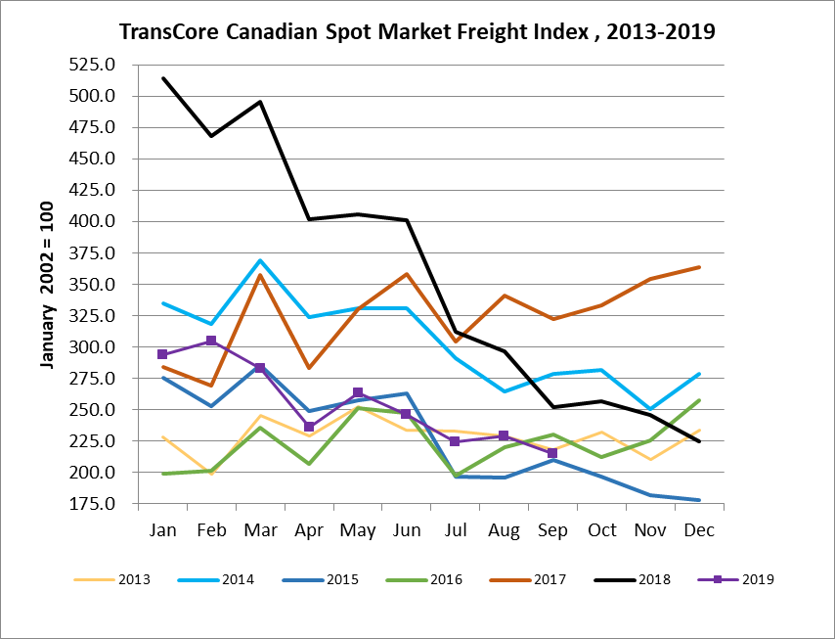

TransCore Canadian Spot Market Truck Index 2013 - 2019
 | 2013 | 2014 | 2015 | 2016 | 2017 | 2018 | 2019 | Percent Change  Y-O-Y | Percent Change M-O-M
Jan | 121 | 104 | 112 | 144 | 136 | 99 | 170 | 72% | 18%
Feb | 114 | 95 | 110 | 157 | 130 | 90 | 149 | 65% | -12%
Mar | 116 | 99 | 127 | 164 | 145 | 104 | 179 | 72% | 21%
Apr | 123 | 108 | 142 | 164 | 130 | 121 | 203 | 68% | 13%
May | 125 | 112 | 140 | 163 | 152 | 141 | 214 | 52% | 5%
Jun | 126 | 111 | 151 | 170 | 142 | 133 | 186 | 40% | -13%
Jul | 139 | 125 | 166 | 162 | 137 | 158 | 213 | 35% | 15%
Aug | 134 | 117 | 155 | 179 | 149 | 172 | 202 | 17% | -5%
Sep | 127 | 122 | 158 | 163 | 132 | 154 | 191 | 24% | -6%
Oct | 139 | 130 | 164 | 161 | 138 | 189
Nov | 125 | 115 | 159 | 163 | 130 | 179
Dec | 105 | 105 | 151 | 133 | 95 | 144

