Canadian Freight Index Highlights:

- Month-over-month: Volumes increased four percent compared to September 2019.
- Year-over-year: Volumes decreased 13 percent compared to October 2018.
- Highlights:
Truck-to-load ratio: The ratio expanded five percent to 4.11 from 3.90 in September. Year-over-year, the truck-to-load ratio increased 28 percent from a ratio of 3.22 trucks for every one load available in October 2018.

Load and Equipment Trend: Despite an overall gain in load volumes, average daily load postings decreased five percent, while average daily truck postings remained unchanged. The monthly change in load volumes came from a seven percent increase in cross-border freight movement while intra-Canadian load volumes stayed consistent. A larger overall 10 percent increase in truck postings drove the truck-to-load balance higher.

Amidst the consistent intra-Canadian load volumes, markets in Western Canada saw large gains in volumes. Notable city-to-city line hauls with improved volumes included: Calgary (AB) to Surrey (BC), Edmonton (AB) to Surrey, Calgary to Langley (BC) lane, and Regina (SK) to Calgary. These lanes saw monthly posting volumes go up an average of 104 percentage points while the Calgary and Edmonton to Surrey lanes saw their highest volumes of 2019.

In terms of cross-border activity, the Montreal (QC) market played a large role for improved performance across several states. The Montreal to Chicago (IL) lane was up just seven percent from last month, but had its strongest showing in the year. The Montreal to Detroit (MI) lane had monthly volumes surge 275 percent and peaked for the year. Other Montreal lanes that demonstrated strong cross-border performance included Laredo (TX) to Montreal, Montreal to Miami (FL), and McAllen (TX) to Montreal. These lanes saw posting volumes jump an average of 75 percent from September.

Cross-Border: Cross-border load postings accounted for 64 percent of the data submitted by Loadlink’s Canadian-based customers.

- Inbound cross-border loads (from the United States to Canada) decreased five percent and outbound loads (from Canada to the U.S.) decreased 19 percent year-over-year.
- Inbound cross-border equipment increased 12 percent and outbound equipment increased 11 percent year-over-year.
Cross-Border Loads into Canada by Region of Destination (with M-O-M volume change):
Ontario: 54 percent | + 12%
Western: 23 percent | + 14%
Quebec: 20 percent | + 9%
Atlantic: 3 percent | + 3%

Cross-Border Equipment into Canada by Region of Destination (with M-O-M volume change):
Ontario: 50 percent | + 11%
Western: 28 percent | + 5%
Quebec: 18 percent | + 13%
Atlantic: 4 percent | + 18%

Intra-Canada: Postings accounted for 34 percent of the data submitted by Loadlink’s Canadian-based customers.

Loads within Canada (with M-O-M volume change):

By Region of Origin |  | By Region of Destination
Ontario: 38 percent | - 3% | Ontario: 38 percent | - 6%
Western: 40 percent | + 11% | Western: 32 percent | + 9%
Quebec: 17 percent | - 7% | Quebec: 26 percent | - 7%
Atlantic: 5 percent | - 12% | Atlantic: 4 percent | - 12%

Equipment Breakdown: The top equipment postings were Dry Vans 53 percent, Reefers 25 percent, Flatbed 17 percent, and Other 5 percent.

TransCore Canadian Spot Market Freight Index 2013 - 2019
 | 2013 | 2014 | 2015 | 2016 | 2017 | 2018 | 2019 | Percent Change Y-O-Y | Percent Change M-O-M
Jan | 228 | 335 | 275 | 199 | 284 | 514 | 294 | -43% | 31%
Feb | 198 | 318 | 253 | 201 | 269 | 468 | 305 | -35% | 4%
Mar | 245 | 369 | 285 | 236 | 357 | 496 | 283 | -43% | -7%
Apr | 229 | 324 | 249 | 207 | 283 | 402 | 236 | -41% | -17%
May | 252 | 331 | 258 | 252 | 330 | 406 | 263 | -35% | 12%
Jun | 234 | 331 | 263 | 247 | 358 | 401 | 246 | -39% | -7%
Jul | 233 | 291 | 197 | 197 | 304 | 312 | 225 | -28% | -9%
Aug | 229 | 264 | 196 | 220 | 341 | 297 | 229 | -23% | 2%
Sep | 218 | 279 | 210 | 231 | 322 | 252 | 215 | -15% | -6%
Oct | 232 | 282 | 197 | 213 | 333 | 257 | 225 | -13% | 4%
Nov | 210 | 251 | 182 | 226 | 354 | 246
Dec | 234 | 278 | 178 | 258 | 364 | 225

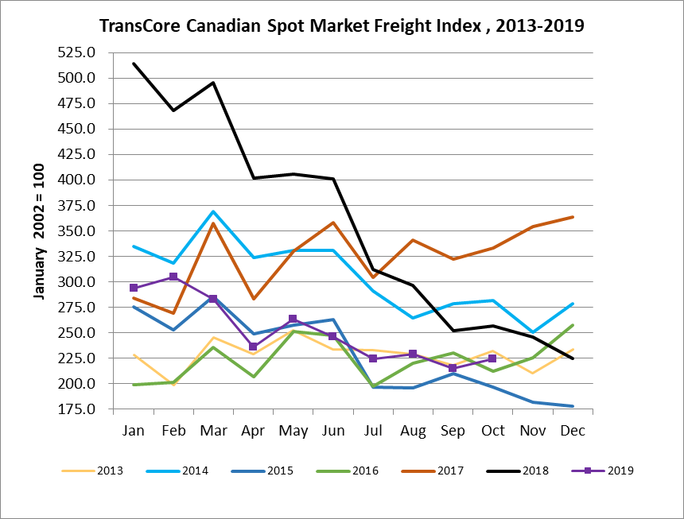

TransCore Canadian Spot Market Truck Index 2013 - 2019
 | 2013 | 2014 | 2015 | 2016 | 2017 | 2018 | 2019 | Percent Change  Y-O-Y | Percent Change M-O-M
Jan | 121 | 104 | 112 | 144 | 136 | 99 | 170 | 72% | 18%
Feb | 114 | 95 | 110 | 157 | 130 | 90 | 149 | 65% | -12%
Mar | 116 | 99 | 127 | 164 | 145 | 104 | 179 | 72% | 21%
Apr | 123 | 108 | 142 | 164 | 130 | 121 | 203 | 68% | 13%
May | 125 | 112 | 140 | 163 | 152 | 141 | 214 | 52% | 5%
Jun | 126 | 111 | 151 | 170 | 142 | 133 | 186 | 40% | -13%
Jul | 139 | 125 | 166 | 162 | 137 | 158 | 213 | 35% | 15%
Aug | 134 | 117 | 155 | 179 | 149 | 172 | 202 | 17% | -5%
Sep | 127 | 122 | 158 | 163 | 132 | 154 | 191 | 24% | -6%
Oct | 139 | 130 | 164 | 161 | 138 | 189 | 210 | 11% | 10%
Nov | 125 | 115 | 159 | 163 | 130 | 179
Dec | 105 | 105 | 151 | 133 | 95 | 144

