Canadian Freight Index Highlights:

- Month-over-month: Volumes decreased two percent compared to January 2020.
- Year-over-year: Volumes decreased nine percent compared to February 2019.
- Highlights:
Truck-to-load ratio: The ratio contracted 10 percent to 2.42 from 2.68 in January. Year-over-year, the truck-to-load ratio rose 13 percentage points from a ratio of 2.14 trucks for every one load available in February 2019.

Load and Equipment Trend: Loadlink’s Canadian spot market continued its strong start to the year with a 13 percent increase in average daily load volumes. The reduced number of workdays caused overall load numbers to fall two percent, but showed impressive improvement on a per day basis.

Cross-Border: Cross-border load postings accounted for 66 percent of the data submitted by Loadlink’s Canadian-based customers.

- Inbound cross-border loads (from the United States to Canada) decreased 11 percent and outbound loads (from Canada to the United States) decreased seven percent year-over-year.
- Inbound cross-border equipment increased five percent and outbound equipment decreased six percent year-over-year.
Cross-Border Loads into Canada by Region of Destination (with M-O-M volume change):
Ontario: | 57 percent | - 18%
Western: | 20 percent | - 14%
Quebec: | 21 percent | - 12%
Atlantic: | 2 percent | - 2%

Cross-Border Equipment into Canada by Region of Destination (with M-O-M volume change):
Ontario: | 49 percent | - 9%
Western: | 29 percent | - 12%
Quebec: | 18 percent | - 4%
Atlantic: | 4 percent | - 7%

Intra-Canada: Postings accounted for 33 percent of the data submitted by Loadlink’s Canadian-based customers.

Loads within Canada (with M-O-M volume change):

By Region of Origin |  |  | By Region of Destination
Ontario: | 32 percent | + 24% | Ontario: | 34 percent | + 17%
Western: | 49 percent | + 15% | Western: | 43 percent | - 1%
Quebec: | 15 percent | + 6% | Quebec: | 20 percent | + 50%
Atlantic: | 4 percent | + 34% | Atlantic: | 3 percent | + 57%

Equipment Breakdown: The top equipment postings were Dry Vans 54 percent, Reefers 25 percent, Flatbed 15 percent, and Other 6 percent.

TransCore Canadian Spot Market Freight Index 2014 - 2020
 | 2014 | 2015 | 2016 | 2017 | 2018 | 2019 | 2020 | Percent Change Y-O-Y | Percent Change M-O-M
Jan | 335 | 275 | 199 | 284 | 514 | 294 | 284 | -3% | 13%
Feb | 318 | 253 | 201 | 269 | 468 | 305 | 278 | -9% | -2%
Mar | 369 | 285 | 236 | 357 | 496 | 283
Apr | 324 | 249 | 207 | 283 | 402 | 236
May | 331 | 258 | 252 | 330 | 406 | 263
Jun | 331 | 263 | 247 | 358 | 401 | 246
Jul | 291 | 197 | 197 | 304 | 312 | 225
Aug | 264 | 196 | 220 | 341 | 297 | 229
Sep | 279 | 210 | 231 | 322 | 252 | 215
Oct | 282 | 197 | 213 | 333 | 257 | 225
Nov | 251 | 182 | 226 | 354 | 246 | 239
Dec | 278 | 178 | 258 | 364 | 225 | 252

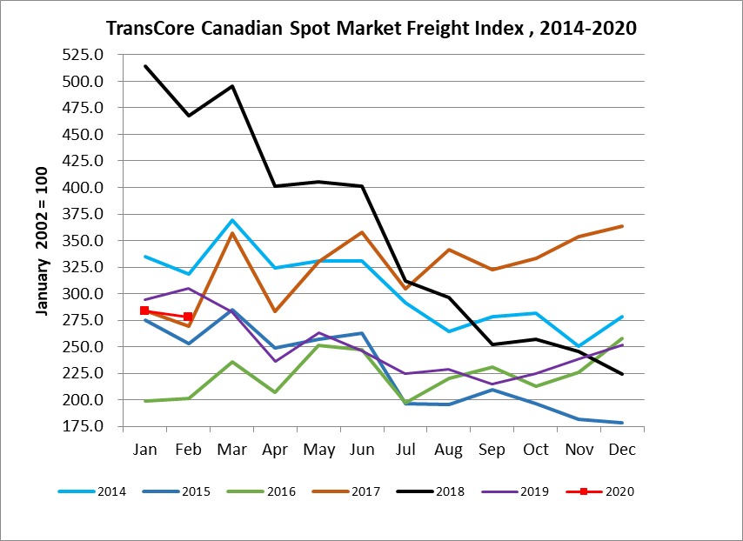

TransCore Canadian Spot Market Truck Index 2014 - 2020
 | 2014 | 2015 | 2016 | 2017 | 2018 | 2019 | 2020 | Percent Change  Y-O-Y | Percent Change M-O-M
Jan | 104 | 112 | 144 | 136 | 99 | 170 | 173 | 2% | 8%
Feb | 95 | 110 | 157 | 130 | 90 | 149 | 153 | 3% | -11%
Mar | 99 | 127 | 164 | 145 | 104 | 179
Apr | 108 | 142 | 164 | 130 | 121 | 203
May | 112 | 140 | 163 | 152 | 141 | 214
Jun | 111 | 151 | 170 | 142 | 133 | 186
Jul | 125 | 166 | 162 | 137 | 158 | 213
Aug | 117 | 155 | 179 | 149 | 172 | 202
Sep | 122 | 158 | 163 | 132 | 154 | 191
Oct | 130 | 164 | 161 | 138 | 189 | 210
Nov | 115 | 159 | 163 | 130 | 179 | 186
Dec | 105 | 151 | 133 | 95 | 144 | 160

