Canadian Freight Index Highlights:

- Month-over-month: Volumes increased 2 percent compared to September 2020.
- Year-over-year: Volumes increased 18 percent compared to October 2019.
Load and Equipment Trend:

Cross-Border: Cross-border load postings accounted for 64 percent of the data submitted by Loadlink’s Canadian-based customers.

- Inbound cross-border loads (from the United States to Canada) increased 35 percent and outbound loads (from Canada to the US) increased three percent year-over-year.
- Inbound cross-border equipment decreased 10 percent and outbound equipment also decreased 10 percent year-over-year.
Cross-Border Loads into Canada by Region of Destination (with M-O-M volume change):
Ontario: 59 percent | + 6%
Western: 18 percent | + 8%
Quebec: 21 percent | + 15%
Atlantic: 2 percent | + 1%

Cross-Border Equipment into Canada by Region of Destination (with M-O-M volume change):
Ontario: 48 percent | + 5%
Western: 31 percent | + 6%
Quebec: 17 percent | + 5%
Atlantic: 4 percent | + 5%

Intra-Canada: Postings accounted for 33 percent of the data submitted by Loadlink’s Canadian-based customers.

Loads within Canada (with M-O-M volume change):

By Region of Origin |  | By Region of Destination
Ontario: 37 percent | + 13% | Ontario: 33 percent | + 16%
Western: 40 percent | + 30% | Western: 40 percent | - 12%
Quebec: 18 percent | - 39% | Quebec: 23 percent | + 38%
Atlantic: 5 percent | + 54% | Atlantic: 4 percent | - 39%
Equipment Breakdown: The top equipment postings were Dry Vans 52 percent, Reefers 28 percent, Flatbed 15 percent, and Other 5 percent.

Loadlink Canadian Spot Market Freight Index 2014 - 2020
 | 2014 | 2015 | 2016 | 2017 | 2018 | 2019 | 2020 | Percent Change Y-O-Y | Percent Change M-O-M
Jan | 335 | 275 | 199 | 284 | 514 | 294 | 284 | -3% | 13%
Feb | 318 | 253 | 201 | 269 | 468 | 305 | 278 | -9% | -2%
Mar | 369 | 285 | 236 | 357 | 496 | 283 | 330 | 17% | 19%
Apr | 324 | 249 | 207 | 283 | 402 | 236 | 146 | -38% | -56%
May | 331 | 258 | 252 | 330 | 406 | 263 | 154 | -42% | 5%
Jun | 331 | 263 | 247 | 358 | 401 | 246 | 219 | -11% | 42%
Jul | 291 | 197 | 197 | 304 | 312 | 225 | 228 | 1% | 4%
Aug | 264 | 196 | 220 | 341 | 297 | 229 | 233 | 2% | 2%
Sep | 279 | 210 | 231 | 322 | 252 | 215 | 260 | 21% | 12%
Oct | 282 | 197 | 213 | 333 | 257 | 225 | 265 | 18% | 2%
Nov | 251 | 182 | 226 | 354 | 246 | 239
Dec | 278 | 178 | 258 | 364 | 225 | 252

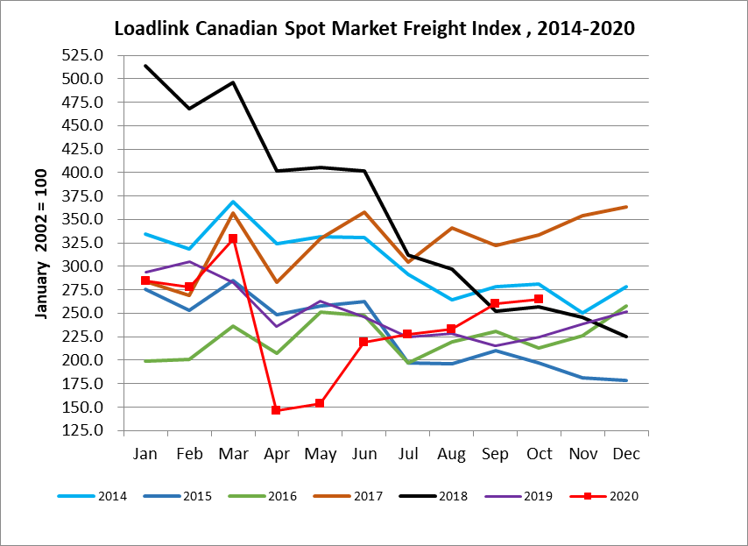

Loadlink Canadian Spot Market Truck Index 2014 - 2020
 | 2014 | 2015 | 2016 | 2017 | 2018 | 2019 | 2020 | Percent Change  Y-O-Y | Percent Change M-O-M
Jan | 104 | 112 | 144 | 136 | 99 | 170 | 173 | 2% | 8%
Feb | 95 | 110 | 157 | 130 | 90 | 149 | 153 | 3% | -11%
Mar | 99 | 127 | 164 | 145 | 104 | 179 | 163 | -9% | 7%
Apr | 108 | 142 | 164 | 130 | 121 | 203 | 188 | -7% | 15%
May | 112 | 140 | 163 | 152 | 141 | 214 | 184 | -14% | -2%
Jun | 111 | 151 | 170 | 142 | 133 | 186 | 191 | 3% | 4%
Jul | 125 | 166 | 162 | 137 | 158 | 213 | 197 | -7% | 3%
Aug | 117 | 155 | 179 | 149 | 172 | 202 | 186 | -8% | -6%
Sep | 122 | 158 | 163 | 132 | 154 | 191 | 192 | 0% | 3%
Oct | 130 | 164 | 161 | 138 | 189 | 210 | 198 | -6% | 3%
Nov | 115 | 159 | 163 | 130 | 179 | 186
Dec | 105 | 151 | 133 | 95 | 144 | 160

