Canadian Freight Index Highlights:

- Month-over-month: Volumes decreased 56 percent compared to March 2020.
- Year-over-year: Volumes decreased 38 percent compared to April 2019.
Load and Equipment Trend: April load volumes on Loadlink’s Canadian spot market were in line with late March predictions of a sharp decline. Overall load volumes on the system decreased 56 percent compared to March, and were down 38 percent compared to April 2019.

Load volumes saw consistent declines from all regions in Canada regardless of cross-border, intra-Canadian, outbound or inbound status. As a result of declining load volumes, truck availability increased 15 percent from March. Less contracted loads due to manufacturing closures would have forced more carriers to look towards the spot market to fulfill their excess capacity. Reduced spot market loads would have further caused carriers with greater exposure to spot freight to post more of their available trucks on the system.
Cross-Border: Cross-border load postings accounted for 68 percent of the data submitted by Loadlink’s Canadian-based customers.

- Inbound cross-border loads (from the United States to Canada) decreased 42 percent and outbound loads (from Canada to the U.S.) decreased 21 percent year-over-year.
- Inbound cross-border equipment decreased three percent and outbound equipment decreased 22 percent year-over-year.
Cross-Border Loads into Canada by Region of Destination (with M-O-M volume change):
Ontario: 55 percent | - 54%
Western: 22 percent | - 66%
Quebec: 21 percent | - 50%
Atlantic: 2 percent | - 46%

Cross-Border Equipment into Canada by Region of Destination (with M-O-M volume change):
Ontario: 46 percent | + 11%
Western: 32 percent | + 33%
Quebec: 17 percent | + 8%
Atlantic: 5 percent | + 34%

Intra-Canada: Postings accounted for 30 percent of the data submitted by Loadlink’s Canadian-based customers.
Loads within Canada (with M-O-M volume change):

By Region of Origin |  | By Region of Destination
Ontario: 28 percent | - 62% | Ontario: 34 percent | - 58%
Western: 50 percent | - 53% | Western: 43 percent | - 46%
Quebec: 17 percent | - 54% | Quebec: 17 percent | - 69%
Atlantic: 5 percent | - 54% | Atlantic: 6 percent | - 46%
Equipment Breakdown: The top equipment postings were Dry Vans 53 percent, Reefers 26 percent, Flatbed 16 percent, and Other 5 percent.

Loadlink Canadian Spot Market Freight Index 2014 - 2020
 | 2014 | 2015 | 2016 | 2017 | 2018 | 2019 | 2020 | Percent Change Y-O-Y | Percent Change M-O-M
Jan | 335 | 275 | 199 | 284 | 514 | 294 | 284 | -3% | 13%
Feb | 318 | 253 | 201 | 269 | 468 | 305 | 278 | -9% | -2%
Mar | 369 | 285 | 236 | 357 | 496 | 283 | 330 | 17% | 19%
Apr | 324 | 249 | 207 | 283 | 402 | 236 | 146 | -38% | -56%
May | 331 | 258 | 252 | 330 | 406 | 263
Jun | 331 | 263 | 247 | 358 | 401 | 246
Jul | 291 | 197 | 197 | 304 | 312 | 225
Aug | 264 | 196 | 220 | 341 | 297 | 229
Sep | 279 | 210 | 231 | 322 | 252 | 215
Oct | 282 | 197 | 213 | 333 | 257 | 225
Nov | 251 | 182 | 226 | 354 | 246 | 239
Dec | 278 | 178 | 258 | 364 | 225 | 252

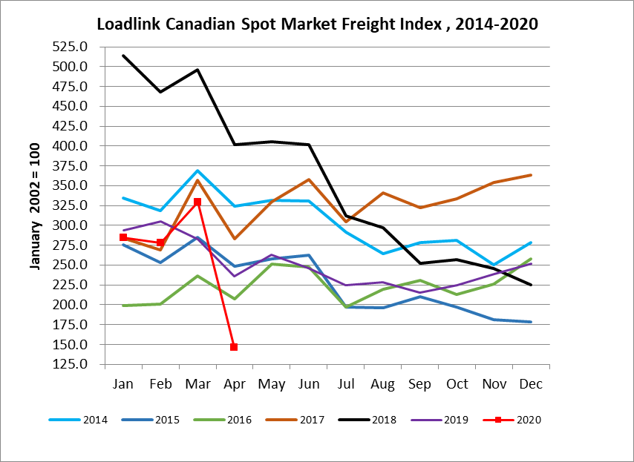

Loadlink Canadian Spot Market Truck Index 2014 - 2020
 | 2014 | 2015 | 2016 | 2017 | 2018 | 2019 | 2020 | Percent Change  Y-O-Y | Percent Change M-O-M
Jan | 104 | 112 | 144 | 136 | 99 | 170 | 173 | 2% | 8%
Feb | 95 | 110 | 157 | 130 | 90 | 149 | 153 | 3% | -11%
Mar | 99 | 127 | 164 | 145 | 104 | 179 | 163 | -9% | 7%
Apr | 108 | 142 | 164 | 130 | 121 | 203 | 188 | -7% | 15%
May | 112 | 140 | 163 | 152 | 141 | 214
Jun | 111 | 151 | 170 | 142 | 133 | 186
Jul | 125 | 166 | 162 | 137 | 158 | 213
Aug | 117 | 155 | 179 | 149 | 172 | 202
Sep | 122 | 158 | 163 | 132 | 154 | 191
Oct | 130 | 164 | 161 | 138 | 189 | 210
Nov | 115 | 159 | 163 | 130 | 179 | 186
Dec | 105 | 151 | 133 | 95 | 144 | 160

